Lab task #10

QUESTION #1

#include<iostream>

using namespace std;

int main()

{

int array[10];

int searching, replacing;

cout << "Enter searchimg value : ";

cin >> searching;

cout << "Enter replacing value : ";

cin >> replacing;

cout << "Enter ten numbers : ";

for (int i = 0; i < 10; i++)

{

cin >> array[i];

if (array[i] == searching)

array[i] = replacing;

}

for (int i = 0; i < 10; i++)

{

if (array[i] == searching)

array[i] = replacing;

cout << array[i] << " ";

}

}

Output

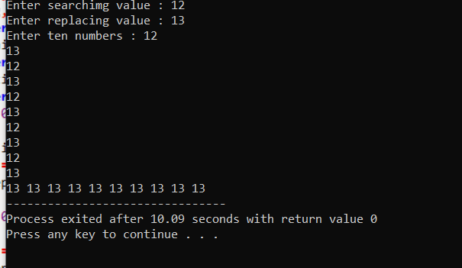

Question #6

#include<iostream>

#include<stdlib.h>

#include<time.h>

using namespace std;

int main()

{

int array[20];

srand(time(0));

for (int i = 0; i < 20; i++)

array[i] = rand() % 50;

for (int i = 0; i < 20; i++)

{

if (array[i] % 3 == 0)

{

cout << array[i] << " :is multiple of 3 " << endl;

}

if (array[i] % 5 == 0)

{

cout << array[i] << " :is multiple of 5 " << endl;

}

if (array[i] % 8 == 0)

{

cout << array[i] << " :is multiple if 8 " << endl;

}

if (array[i] % 13 == 0)

{

cout << array[i] << " :is multiple of 13 " << endl;

}

System(“pause”);

return 0;

}